|  |
| --- |
| Flow Control |

## Stop&Wait, Go-Back-N & Selective Repeat

Your task is to design and implement two flow control approaches based on code available in Blackboard. The aim of the assignment is to get to know sockets, datagram packets and threads and to design a protocol i.e. packet layout and packet handling, for communication between two nodes.

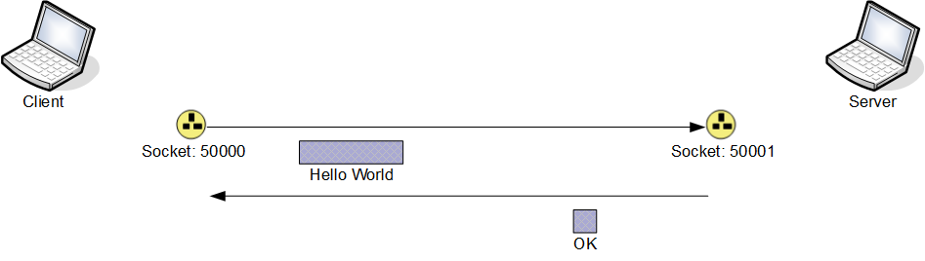

Figure : Current simplistic implementation

The current implementation provides functionality that transmits a packet from a client to a server, containing a String entered by the user. The server responds to incoming packets with a packet containing the String “OK”. The Client opens a port on port number 50000, creates a packet from the input provided by the user and sends this packet to another port on the local machine with the port number 50001.

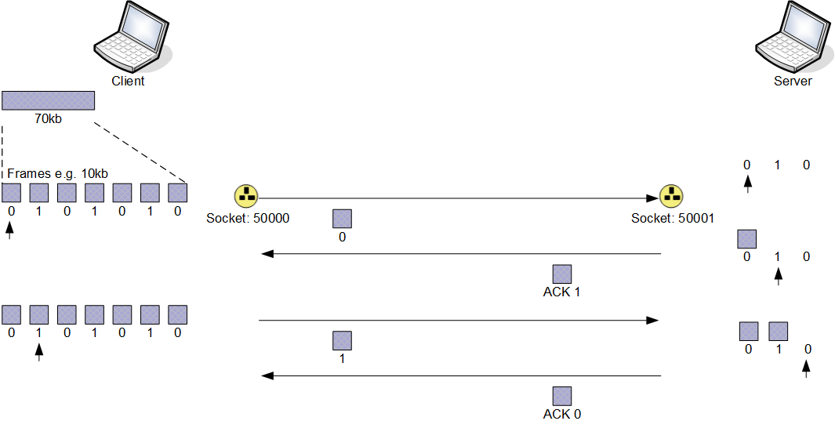

Figure : Scenario that your implementation should address

The first step is the implementation of a Stop&Wait protocol. Your implementation should allow the Client to send a number of packets, one after the other, using Stop&Wait to ensure that the receiver is able to handle the incoming packet. The implementation will have to assign alternating numbers, 0 and 1, to packets and the acknowledgements by the Server will have to indicate the number of the packet the Server expects next.

A good solution should include an implementation of a timer at the sender and the receiver to indicate time-outs and a retransmission mechanism of an already transmitted packet. The setSoTimeout method of the DatagramSocket class causes an exception to be thrown if a receive method has not returned within a given time. This timeout mechanism may form the basis for a timer mechanism.

The second step for the assignment is the implementation of a sliding window approach, either Go-Back-N or Selective Repeat. In your implementation, the client should establish a connection to the server, take consecutive chunks of a buffer and send these chunks to the server. The server should acknowledge the chunks that it receives. In the example in figure 1, the sequence numbers are limited to 0...3; in your implementation, the sequence number should be limited to 0…15.

The implementation should be accompanied by a report that explains the design and implementation of the two protocols, the choices that you have made and the advantages and disadvantages that these decisions introduced.

### Submission Details

The files that contain the implementation and the report should be submitted through Blackboard. Every file should contain the name of the author and the student number. The source files of the implementation should be submitted as an archived file e.g. “.zip” or “.tar.gz”. The report should be submitted as either word- or pdf-document.

The name of the archive file and the report should be include the name and the student number of the author; for example, “123456-John-Doe-FlowC-implement.zip” and “123456-John-Doe-FlowC-Report.pdf” where the name of the student is John Doe and the student # is 123456. The deadline for the submission is given in Blackboard.

### Marking Scheme

The marks for the assignment will be split into 20% for continuous engagement, 40% for the implementation of Stop&Wait and 40% for the implementation of a sliding window approach. The marks for the implementations will be split 50% for the implementation and 50% for the documentation through the report.